Vulnerability 3: DOM-Based XSS in Search

CWE: CWE-79 - Improper Neutralization of Input During Web Page Generation
OWASP: A03:2021 - Injection
CVSS: 6.1 (Medium)
Location: roufrontend/src/app/search-result/search-result.component.ts
Component: Frontend - Search result page (Angular SPA)

Description
The product search page reads the q query parameter from the URL and injects it directly into the DOM using Angular's bypassSecurityTrustHtml() method. This explicitly disables Angular's built-in HTML sanitization, meaning any HTML or JavaScript in the search term is rendered as executable content. An attacker can craft a URL containing a malicious payload that executes in the victim's browser when the link is opened.
Unlike server-reflected XSS, this vulnerability lives entirely in client-side code. The server never sees the payload in a dangerous form the DOM manipulation happens in the browser after the page loads.

Vulnerable code (Backend):
this.searchValue = queryParam
if (this.gridDataSourceSubscription) {
this.gridDataSourceSubscription.unsubscribe()
}

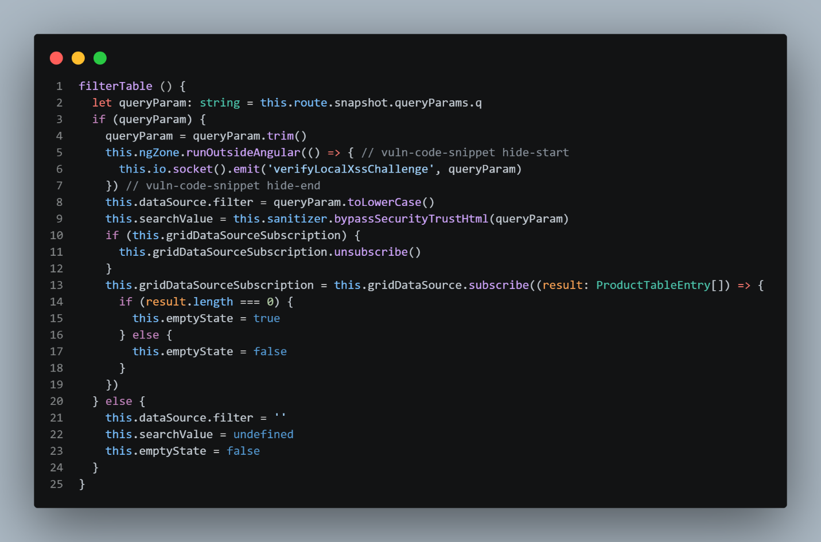
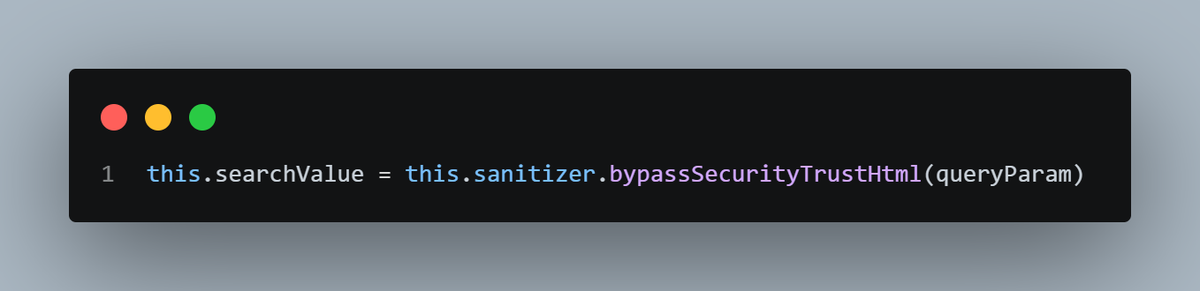

The bypassSecurityTrustHtml() call tells Angular to treat the string as safe HTML. Combined with a template binding like [innerHTML]="searchValue", this renders attacker-controlled HTML directly into the DOM. The queryParam value comes from this.route.snapshot.queryParams.q the q parameter in the URL, fully attacker controlled.

Exploit payload: <iframe src="javascript:alert('XSS')"></iframe>
http://localhost:3000/#/search?q=<iframe src="javascript:alert('XSS')"></iframe>
- Craft the URL with the payload in the q parameter
- Send it to a victim or open it directly in the browser
- The search page loads and the payload is injected into the DOM
- The JavaScript in the src attribute executes, triggering the alert

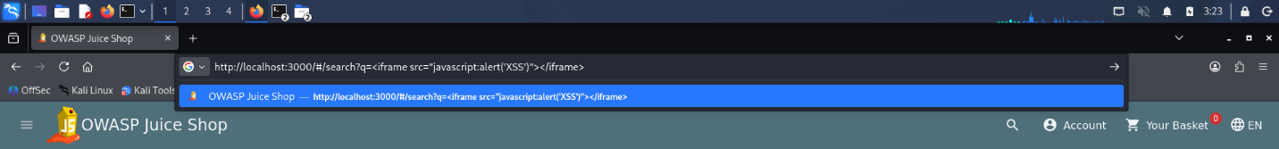

The Vulnerability:

Component | Role
URL q parameter | Attacker-controlled input source
bypassSecurityTrustHtml() | Disables Angular's XSS protection
[innerHTML] binding in template | Renders the string as executable HTML
<iframe src="javascript:..."> | Executes JavaScript when rendered

Evidence - Before Fix
- The search page loads, and the payload is injected into the DOM via Angular's bypassSecurityTrustHtml() method, which disables built-in HTML sanitization.
- The JavaScript in the src attribute executes immediately in the browser, triggering the alert dialog with the message "XSS" over the Juice Shop search page.
- Below showing the alert dialog displayed on top of the search results page, confirming arbitrary JavaScript execution in the victim's browser session.

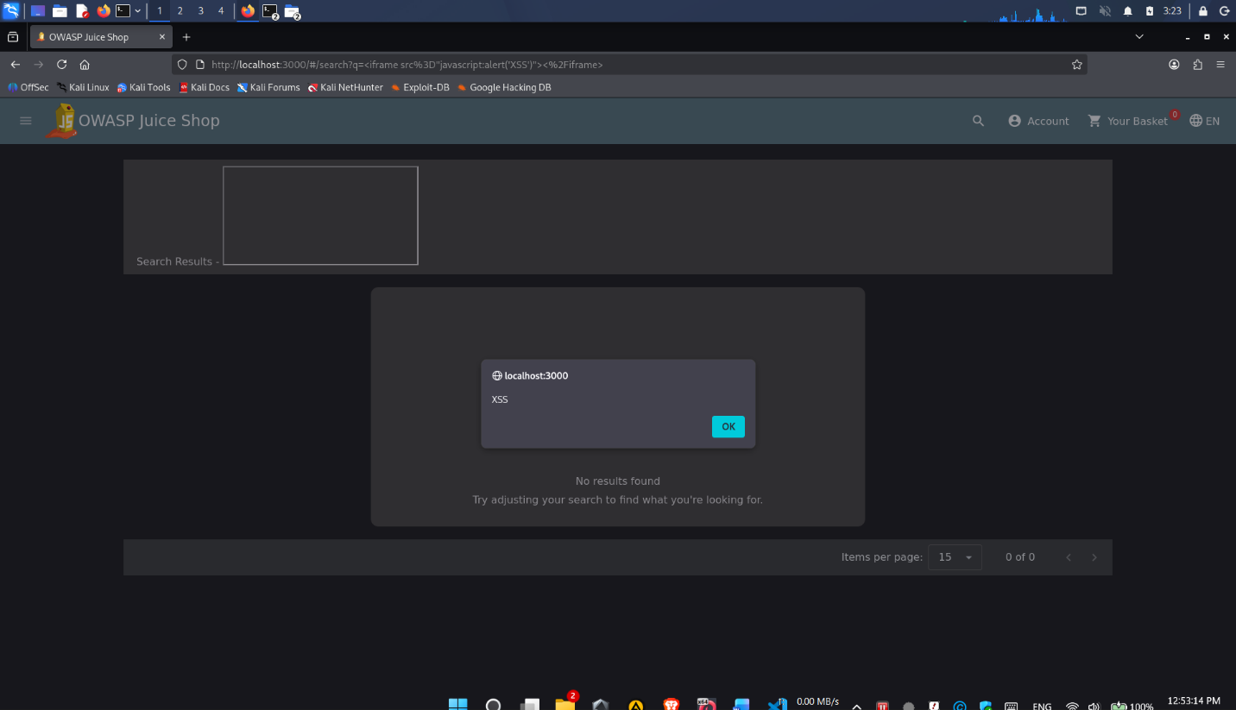

SAST Detection - Before Fix
Tool: Semgrep
Rule: Custom rule targeting bypassSecurityTrustHtml on user input
Run against the unmodified roufrontend/src/app/search-result/search-result.component.ts, Semgrep flags the interpolated query. Capture the finding count and the specific rule ID and line number flagged.

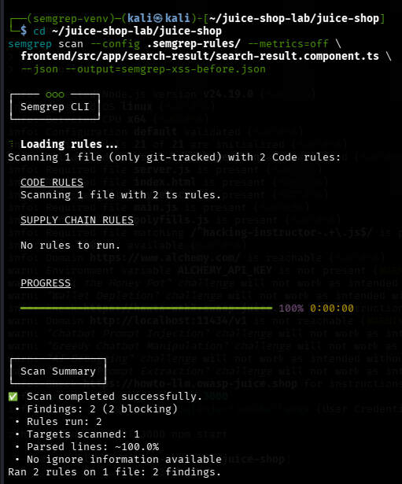
Secure Coding Fix
Remove the bypass call and rely on Angular's built-in output encoding.
this.searchValue = queryParam
if (this.gridDataSourceSubscription) {
this.gridDataSourceSubscription.unsubscribe()
}

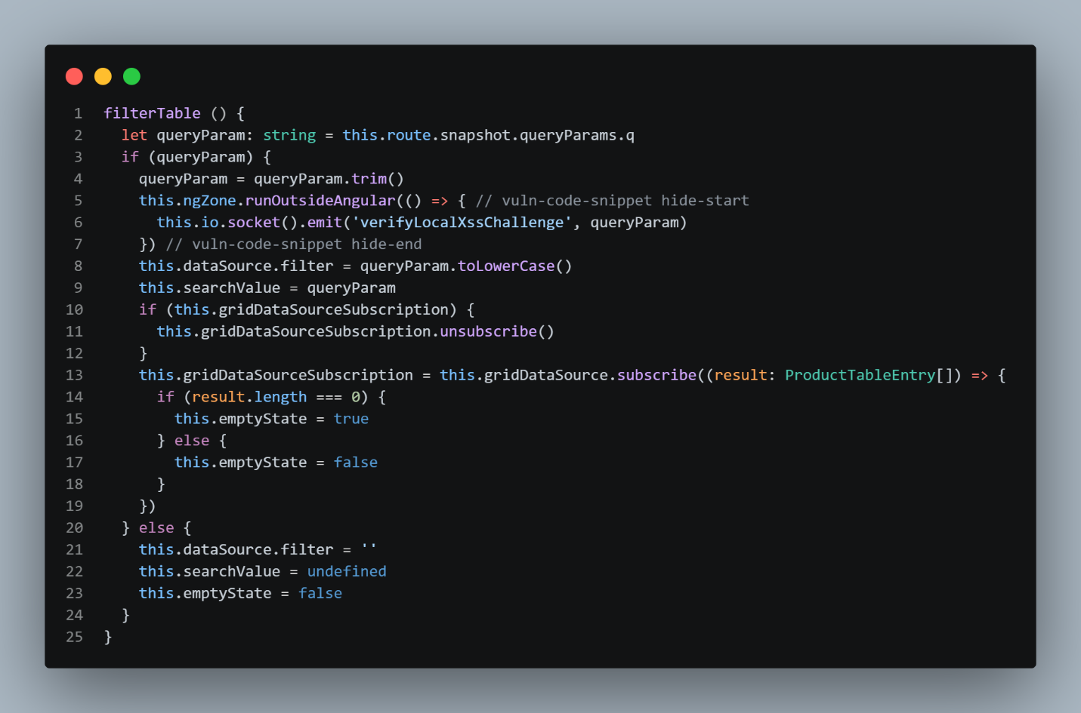
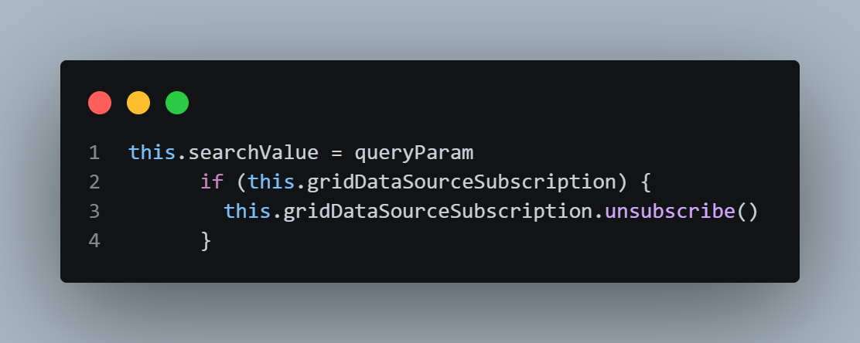

Why this works: Angular's {{ }} interpolation performs context-aware output encoding. Characters like <, >, &, and " escaped to safe HTML entities before insertion into the DOM. The payload is displayed as text rather than parsed as HTML, so no script executes.

Evidence - After Fix

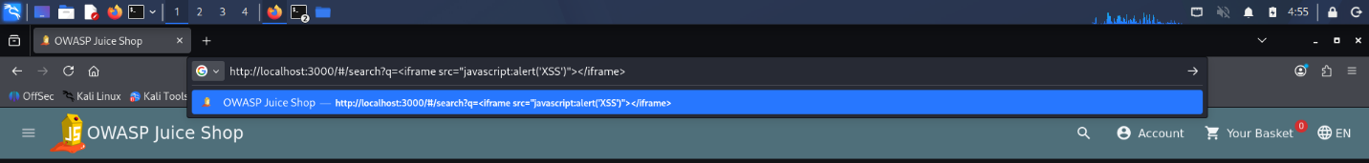
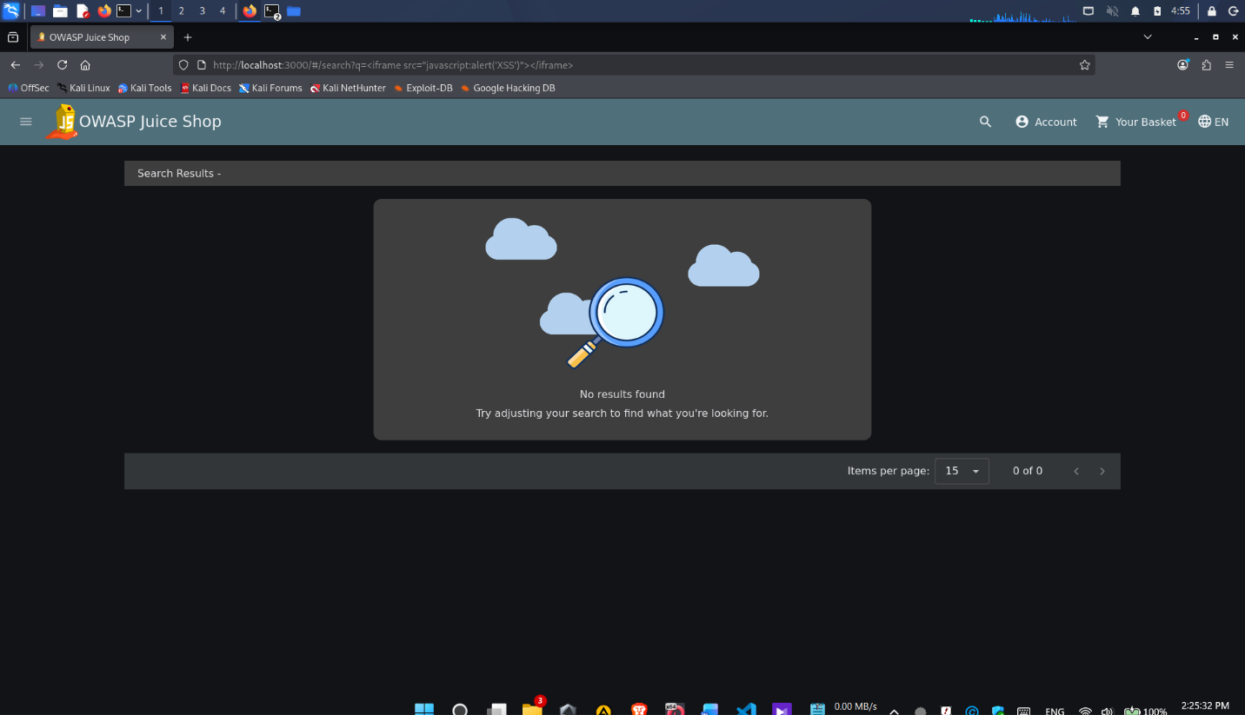

SAST Detection - After Fix
Re-running the same scan on the patched roufrontend/src/app/search-result/search-result.component.ts shows the SQL injection finding is gone.

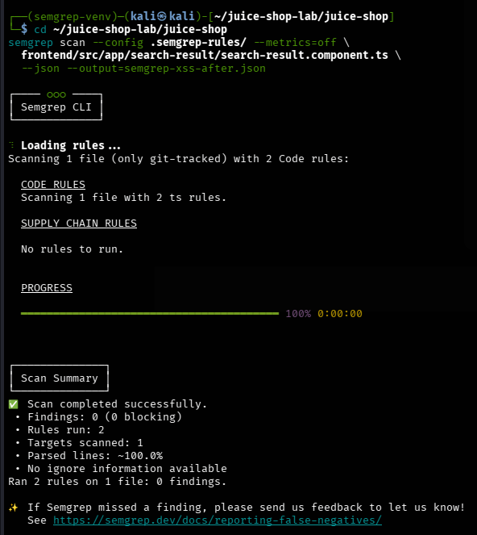
Before / After Summary

Metric | Before Fix | After Fix
Semgrep finding count on component | 1 | 0
Exploit payload renders | Alert fires | Rendered as text
DOM sink | bypassSecurityTrustHtml() + [innerHTML] | Interpolation {{ }}
Root cause present | Yes | No
CWE-79 compliant | No | Yes

